ASSIGNMENT 6
Applying AI-Based Style Transfer to an Image


orginal.jpg
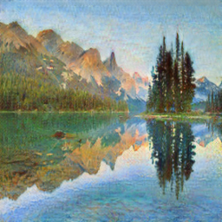

cycleGAN_output.png
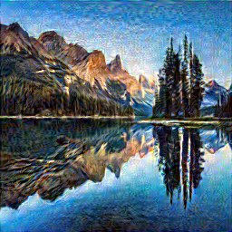

neural_style_output.png
Written Comparison
- Content Preservation: Neural Style Transfer preserved the original content better because the mountains, lake, trees, and overall structure remained recognizable.
- Style Transformation: CycleGAN produced a stronger overall style transformation, giving the landscape a more painting-like appearance.
- Difference: Neural Style Transfer retained the original scene while applying the visual characteristics of the selected painting, whereas CycleGAN changed the overall visual appearance more noticeably.
- Cycle Consistency: CycleGAN uses cycle consistency, which helps preserve important image information by encouraging the transformed image to be recoverable back to its original domain.

